EmplaceAV

User Manual

Contents

Windows 3

Setting up Orion32 3

Using EmplaceAV 5

Usage Constraints and Limitations 7

Audio 7

Video 7

Windows 7

Mac 7

# Windows

## Setting up Orion32

1. Install the Orion32 drivers from <https://support.antelopeaudio.com/support/solutions/articles/42000017482-orion32-download-section>
2. Plug the Orion32 to the computer through a USB connection
3. Open sound settings by right clicking on the speaker icon in the system tray and selecting “Sounds”

https://puu.sh/Dv6Bl/71fba77ba4.png

Figure 1 Speaker icon in system tray

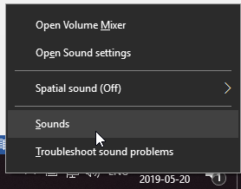

Figure 2 Right click speaker icon and select "Sounds"

1. In the sound settings, go to the “Playback” tab and make sure the Orion32 is selected as the default playback device

https://puu.sh/Dv6DG/c4588f28bf.png

Figure 3 Select the "Playback" tab

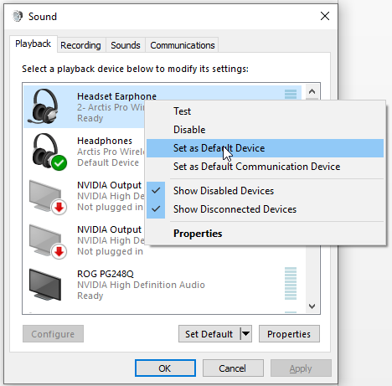

Figure 4 Set the Orion32 as default device

1. Right click the Orion32, go to properties, and go to the “Advanced” tab

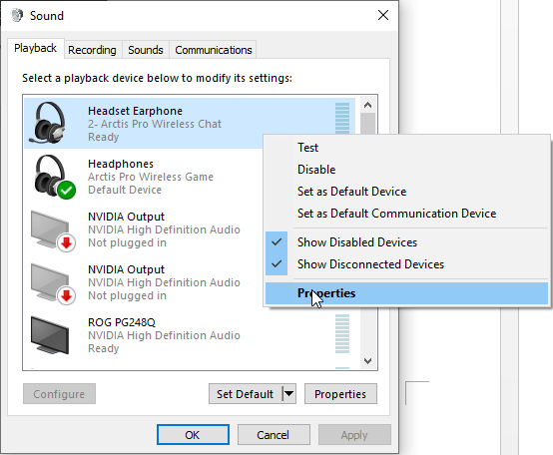

Figure 5 Go to properties of Orion32

https://puu.sh/Dv6XU/0391bd3ff9.png

Figure 6 Select the "Advanced" tab

1. Select the default format to be 32 channels, 16 or 32 bits, and 44100 Hz, then hit apply

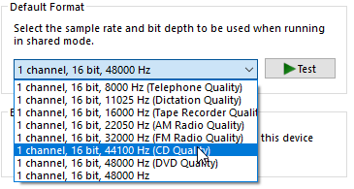

Figure 7 Select the correct format

https://puu.sh/Dv6YL/881d025a3d.png

Figure 8 Make sure to apply the settings

## Using EmplaceAV

1. Name the audio files 1.wav to 32.wav in order of which channel/speaker they’re associated with, and name the video file video.mp4. Place all the media content inside the media folder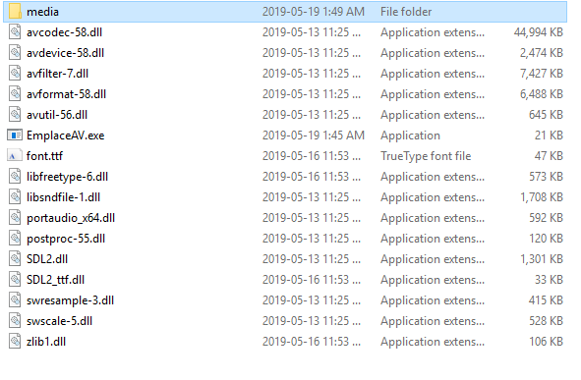

Figure 9 The media files go in the media folder in the root of the program

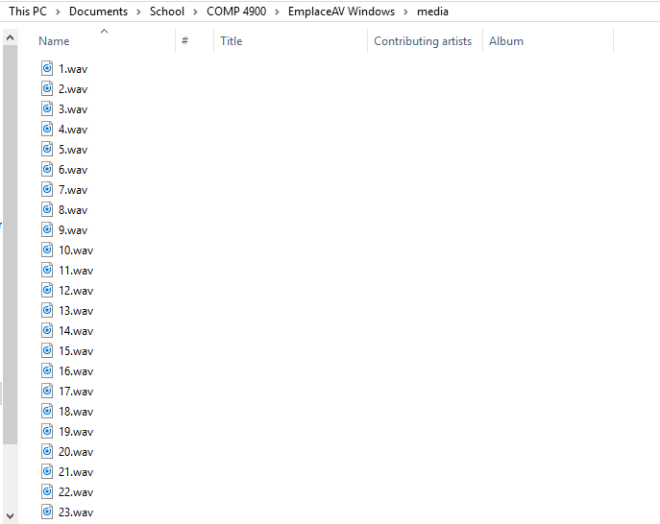

Figure 10 Correctly name the sound and video files

1. Double click EmplaceAV.exe to open the playback menu

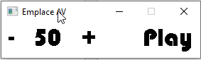

Figure 11 The EmplaceAV playback menu

* 1. Adjust the playback volume by clicking the plus(+) and minus(-) buttons
  2. Drag the menu to whichever screen designated for video playback
  3. Click the play button to start full screen playback

1. To close the application, click the x button for the console

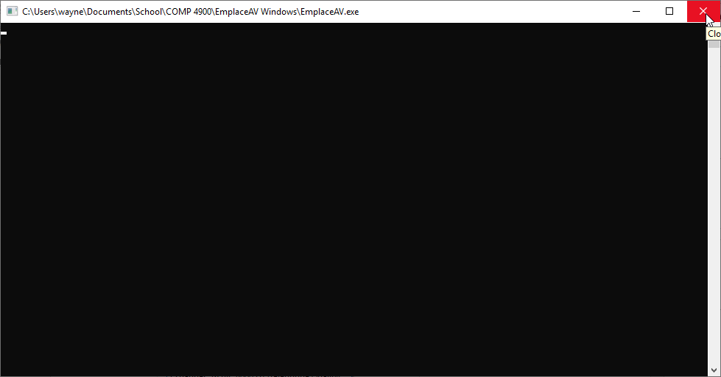

Figure 12 Click the x on the console to close the application

# Usage Constraints and Limitations

## Audio

* The wav files must be mono channel
* The wav files should be the same length. The audio will stop playing when the first audio file finishes playing, therefore, the shortest audio file should be at minimum longer than the video file
* The audio files need to have the same sample rate as the device, by default this is 44100 Hz

## Video

## Windows

* The device needs to be configured to have the same sample rate as the audio or else there will be no sound, by default this is 44100 Hz
* There are some devices that have issues with connecting to the Orion32 over USB. If connecting the Orion32 gives you a resource error, please contact the manufacturer or look up possible solutions as this is an issues between the device and the USB controller

## Mac